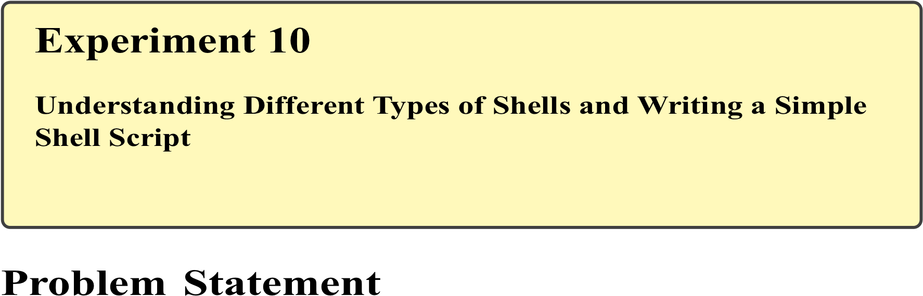
In Linux, the shell acts as an interface between the user and the operating system kernel. Different types of shells provide varied features, scripting capabilities, and command-line behaviors. Among these, Bash (Bourne Again Shell) is the most widely used shell due to its scripting power and ease of use.
The problem is to identify different types of shells available in Linux, understand their characteristics, and write and execute a simple shell script using Bash, including the use of variables.

Theory

Shell in Linux
A shell is a command-line interpreter that processes user commands and communicates with the kernel. It allows users to execute commands, manage files, and write scripts for automation.

Types of Shells
Common shells available in Linux include:
Shell | Description
sh | Original Bourne Shell
bash | Bourne Again Shell (default)
ksh | Korn Shell
csh | C Shell
zsh | Z Shell

Bash Shell
Bash is an enhanced version of sh that supports:
- Command history
- Job control
- Scripting with variables and control structures

Shell Scripts
A shell script is a file containing a sequence of commands executed by the shell. It typically starts with a shebang (#!/bin/bash) that specifies the interpreter.

Commands Used
cat /etc/shells | List available shells
echo $SHELL | Display current shell
bash | Start Bash shell
sh | Start Bourne shell
chmod | Change file permissions
./script.sh | Execute shell script

Procedure

A. Identifying Different Shells
Open the terminal.
List available shells:
cat /etc/shells
Check the current shell:
echo $SHELL

B. Switching Between Shells Switch to Bourne shell: sh
Return to Bash: exit

C. Writing a Simple Bash Script
Create a new script file:
nano simple.sh
Enter the following script:
#!/bin/bash
echo "Welcome to Linux Shell Scripting" name="Student" echo "Hello $name"
Save and exit the editor.

D. Executing the Script
Provide execute permission: chmod +x simple.sh
Run the script:
./simple.sh
